**Online Library Management System (OLMS) Documentation**

Our online library management system built with JSP and oracle database lets you do manage your library in and efficient way. Whether it is adding books, members and issue books, our system lets you do these very easily. Our documentation has all of the information needed to run our system efficiently.

**Features of OLMS**

Logging into the system

Upon opening OLMS, the user is greeted with a logging screen. The OLSM can be accessed very easily by using a set credentials.

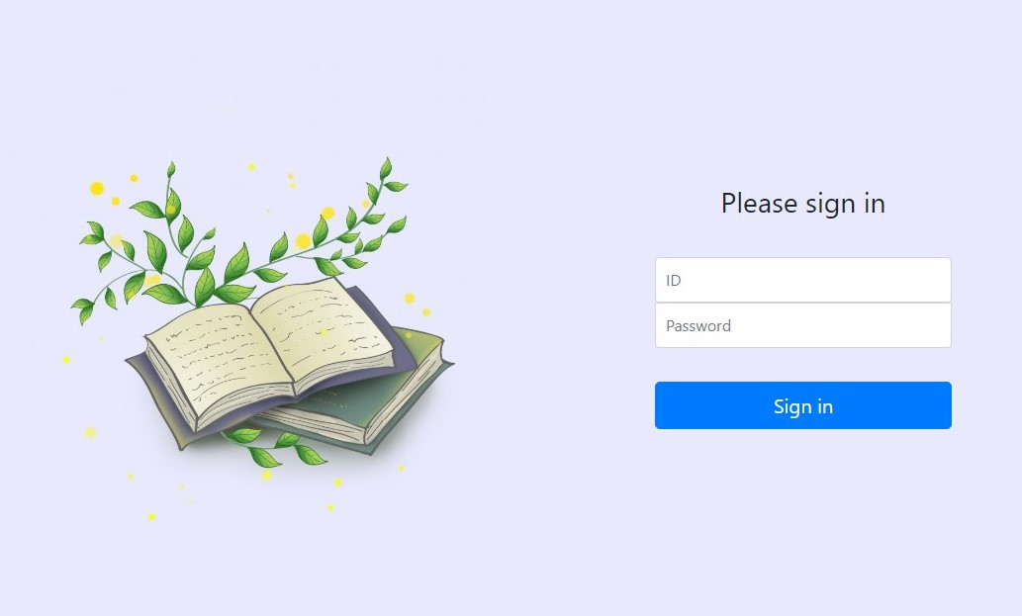

Dashboard

Once a user logs in as an admin, he or she will be presented with the following screen. The logged in users name will also be displayed all the time in the top right corner of the screen.

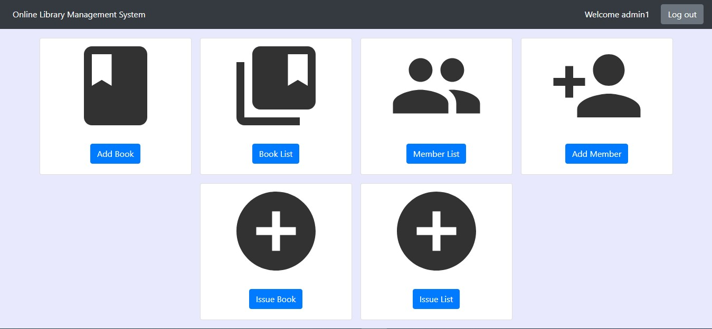

Adding Books

Click on the add book option with redirect you to a new page where you can a new book.

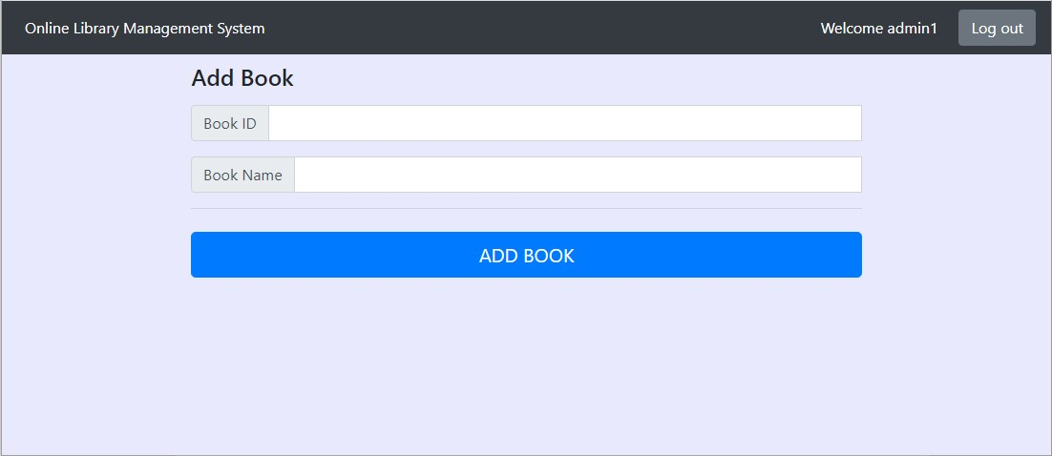

Seeing list of books

Clicking on the “Book List” option, will take you to a page where you will be presented with a page showing the list of books in the OLMS. From here you can edit or delete books.

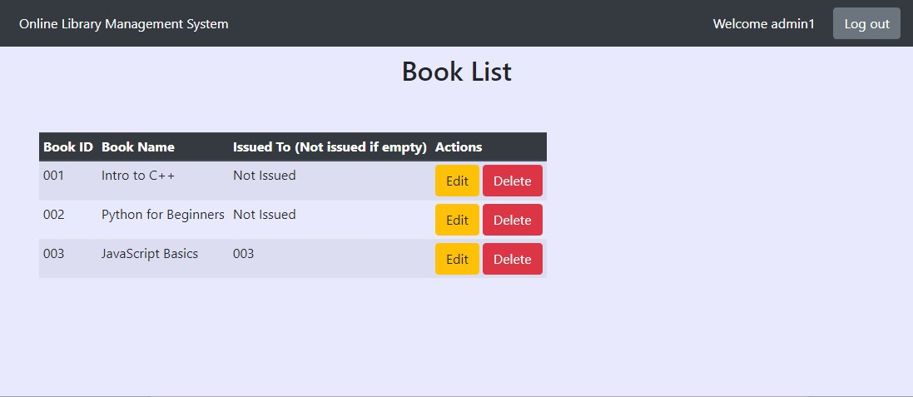

Editing and Deleting a Book

From the book list page, you can click on the delete or edit button for each book.

Clicking the delete button will delete the book.

Clicking on the edit button will take you the edit button page where you can edit the book parameters.

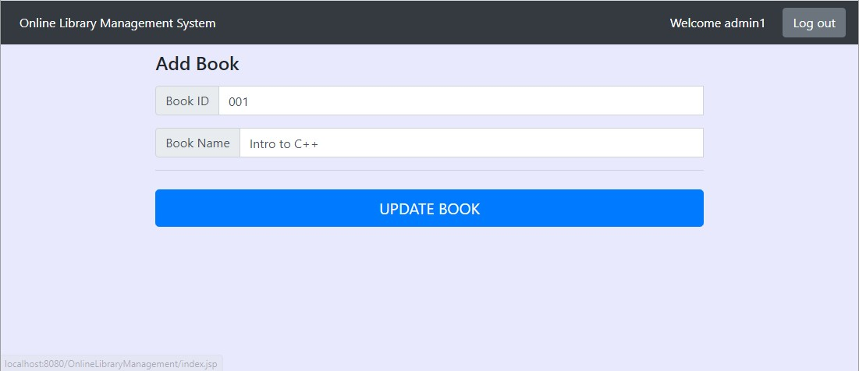

Seeing list of members

Clicking on the “Member List” option, will take you to a page where you will be presented with a page showing the list of members in the OLMS. From here you can edit or delete members.

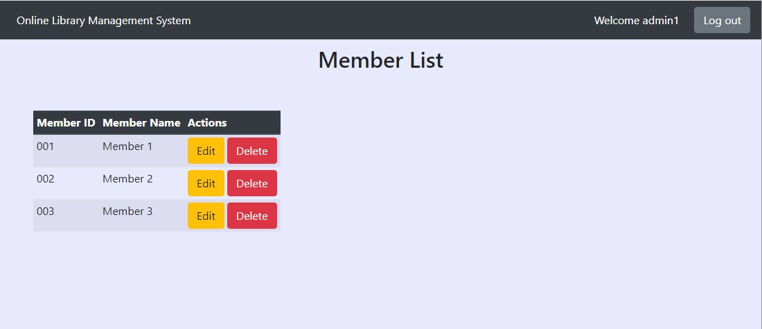

Editing and Deleting a Member

From the member list page, you can click on the delete or edit button for each member.

Clicking the delete button will delete the member.

Clicking on the edit button will take you the edit button page where you can edit the member parameters.

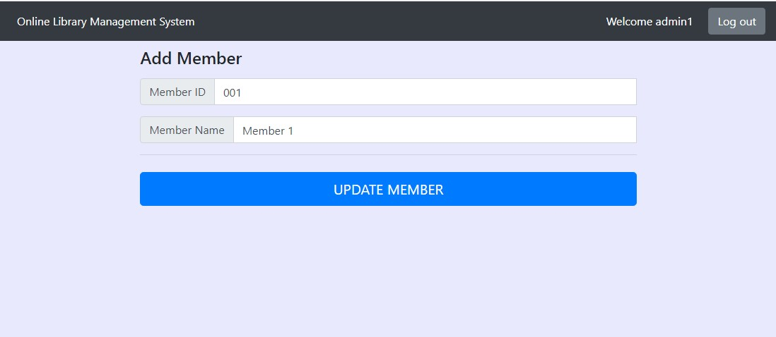

Adding members

Click on the add member option with redirect you to a new page where you can a new member.

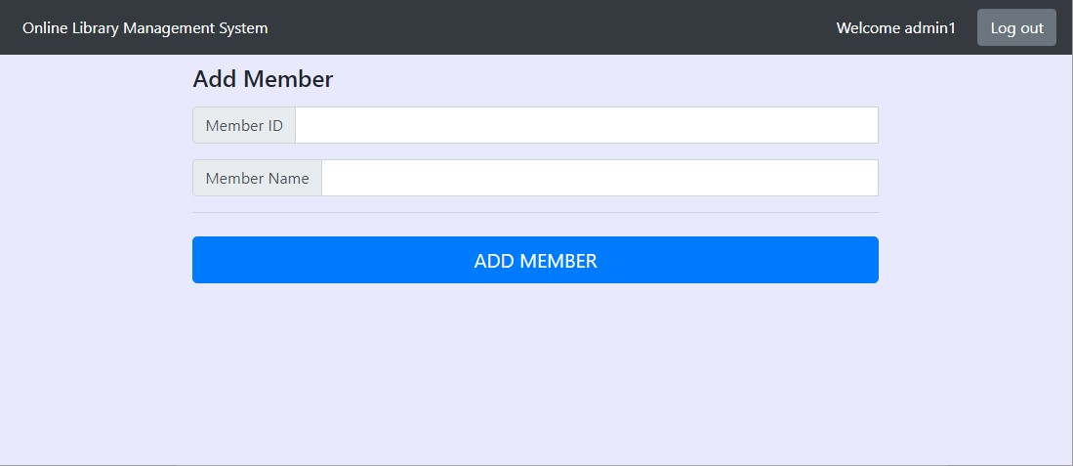

Issuing books

Clicking on the “Issue Book” will take you to the page where you can issue books. Here you need to enter the Book ID and Member ID

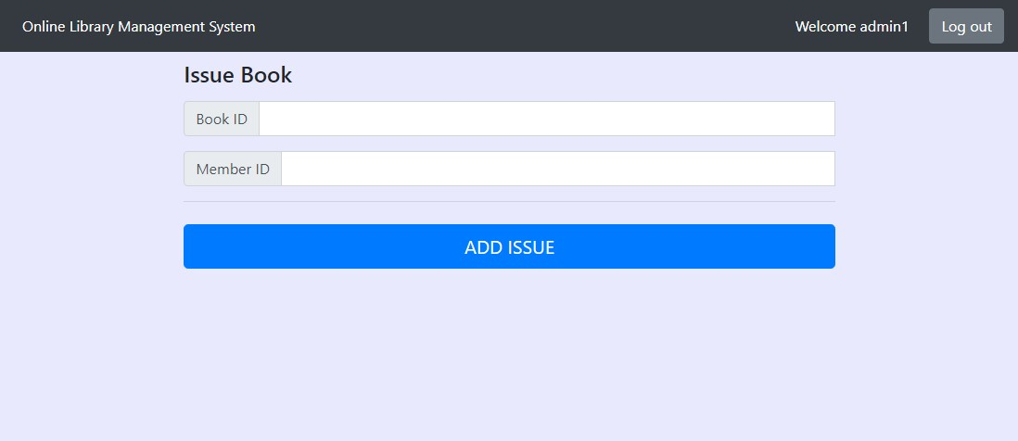

Issuing List

Issue list button will take you to page where you can see the list of books issued. Here you can edit or delete an issue.

